Homework Assignment 5

Name: Asrar Syed
Due by: April 11, 2025
Course Section: CSC 4320-034

- (5 points) Suppose that a system is in an unsafe state. Show that it is possible for the threads to complete their execution without entering a deadlocked state. Show by an example.

An unsafe state simply means that there is no guaranteed sequence in which all threads can finish even if each one requests its maximum resources. It does not mean a deadlock will definitely occur—it just might.

Let’s consider a system with:
- 3 processes (P0, P1, P2)
- 11 resource allocated

 | Max | Allocated | Need
P0 | 7 | 5 | 2
P1 | 4 | 2 | 2
P2 | 9 | 3 | 6

Total allocated = 5 + 2 + 3 = 10, so Available = 1

At this point, no process can immediately receive the resources it needs to finish. Therefore, the system is in an unsafe state, because there is no guaranteed safe sequence in which all processes can finish if they all simultaneously request their maximum needs.

However, this does not mean the system will enter a deadlock:

- For instance, if P0 does not request its remaining 2 resources immediately and instead waits, then no deadlock occurs.
- Suppose P0 holds off and later voluntarily releases its 5 allocated resources (after finishing other work or being preempted). This brings the available resources to 1 + 5 = 6.
- Now, P2, which needs 6, can acquire them, finish, and release its 3 resources — making 6 + 3 = 9 available.
- Finally, P1, which needs 2, can proceed, finish, and release its 2 resources.

In this way, even though the system started in an unsafe state, all processes can complete successfully without entering a deadlock, if requests are made in a favorable order.

- Consider the following snapshot of a system:
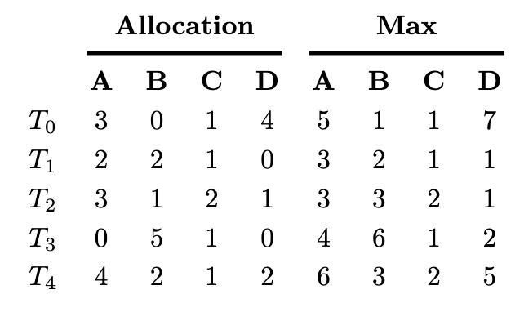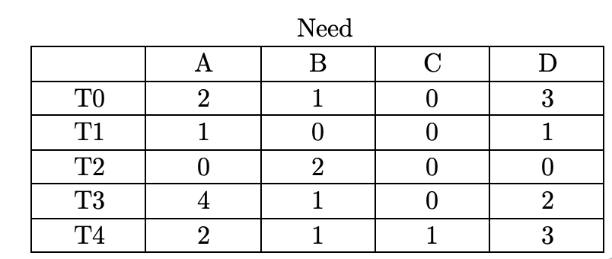
Using the banker’s algorithm, determine whether or not each of the following states is unsafe. If the state is safe, illustrate the order in which the threads may complete. Otherwise, illustrate why the state is unsafe.

- (5 points) Available = (0,3,0,1) - Safe sequence exists: T2 -> T1 -> T3 -> T0 -> T4

- T2: Need = (0,2,0,0) => OK
  - Runs, releases (3,1,2,1)
  - Available = (3,4,2,2)
- T1: Need = (1,0,0,1) => OK
  - Runs, releases (2,2,1,0)
  - Available = (5,6,3,2)
- T3: Need = (4,1,0,2) => OK
  - Runs, releases (0,5,1,0)
  - Available = (5,11,4,2)
- T0: Need = (2,1,0,3) => OK
  - Runs, releases (3,0,1,4)
- T4: Need = (2,1,1,3) => OK
  - Runs, releases (4,2,1,2)

- 5 points) Available = (1,0,0,2) - Safe sequence exists: T1 -> T2 -> T3 -> T4 -> T0

- T1: Need = (1,0,0,1) => OK
  - Runs, releases (2,2,1,0)
  - Available = (3,2,1,2)
- T2: Need = (0,2,0,0) => OK
  - Runs, releases (3,1,2,1)
  - Available = (6,3,3,3)
- T3: Need = (4,1,0,2) => OK
  - Runs, releases (0,5,1,0)
  - Available = (6,8,4,3)
- T4: Need = (2,1,1,3) => OK
  - Runs, releases (4,2,1,2)
  - Available = (10,10,5,5)
- T0: Need = (2,1,0,3) => OK
  - Runs, releases (3,0,1,4)
  - Available = (13,10,6,9)
- (15 points) Which of the six resource-allocation graphs shown below illustrate deadlock? For those situations that are deadlocked, provide the cycle of threads and resources. Where there is not a deadlock situation, illustrate the order in which the threads may complete execution.

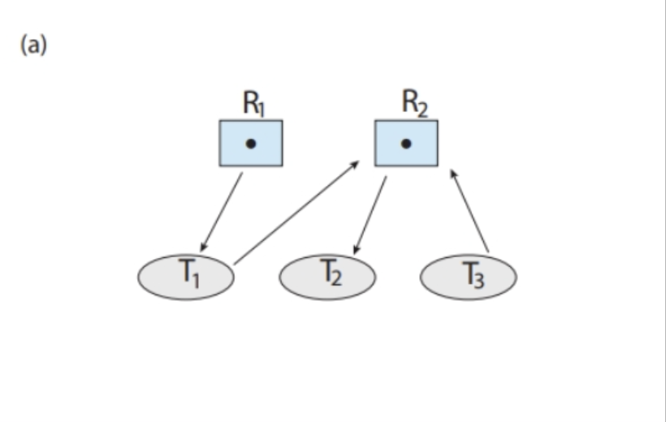 | 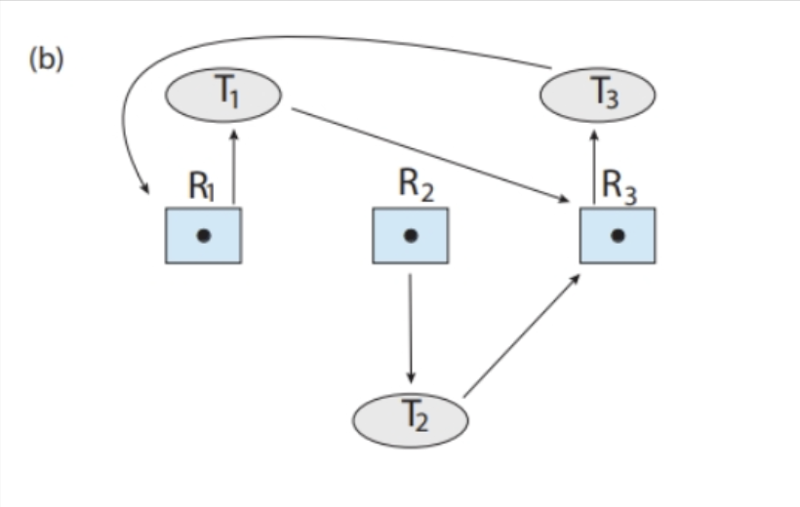
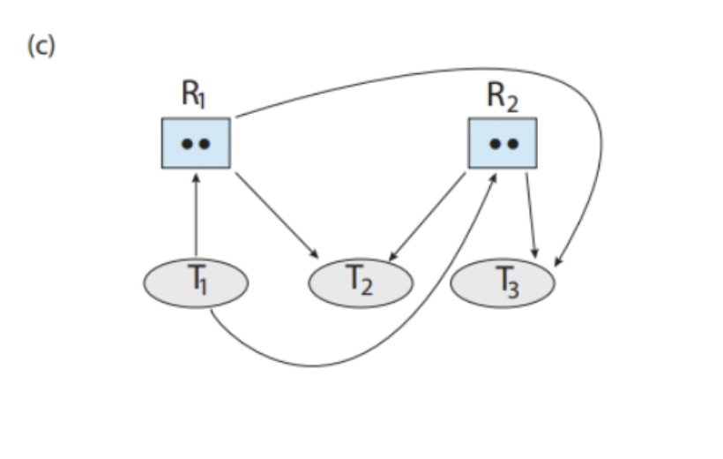 | 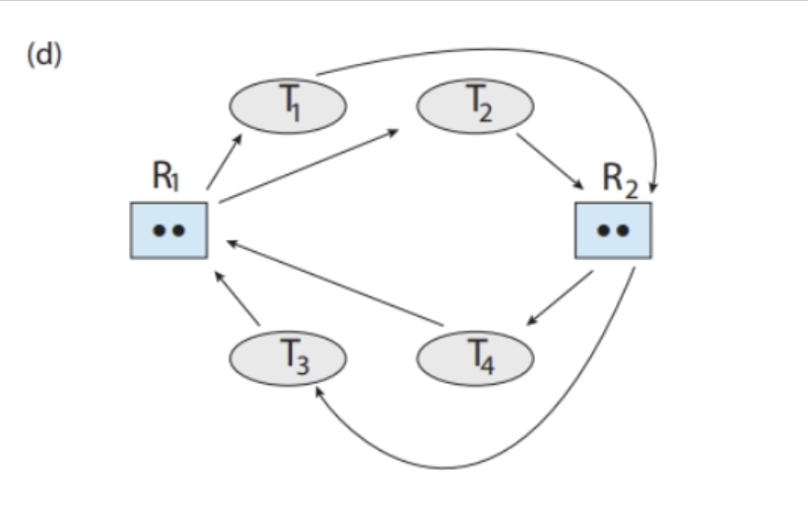
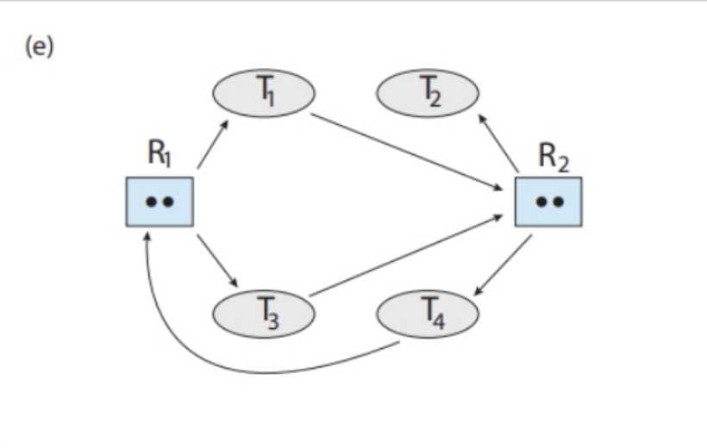 | 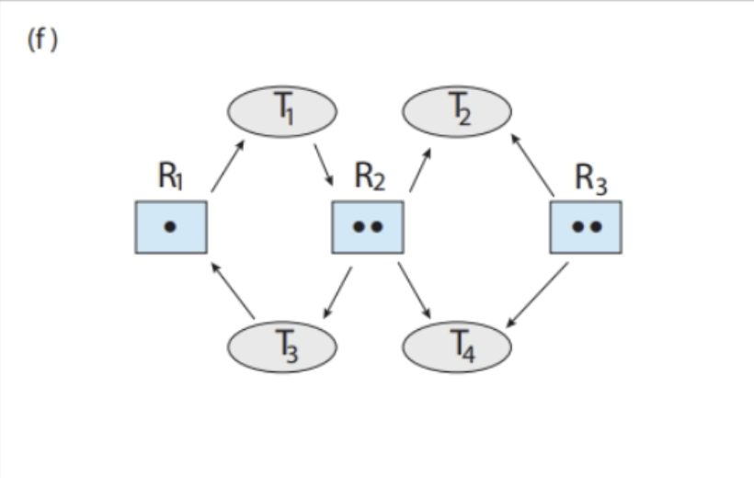
Figure 1: Resource Allocation Graph.

- T2 —> T3 —> T1 (No Deadlock)
T2 releases resources, since its not waiting for instance of resource
- R1 —> T1 —> R3 —> T3 —> R1 (Deadlock Exists)
This is deadlock, since it cycles back to R1, not freeing any resources
- T2 —> T3 —> T1 (No Deadlock)
T2 and T3 can release resources, since its not waiting for instance of resource
- R1 —> T1 —> R3 —> T3 —> R1 (Deadlock Exists)
This is deadlock, since it cycles resources back to R1, not freeing any
- R1 —> T1 —> R2 —> T2 (No Deadlock)
T2 can release resources, not holding onto any or passing it into sycle
- R1 —> T1 —> R2 —> R4 (No Deadlock)
T2 and T4 can release resources, since its not waiting for instance of resource type
- (20 points) Implement Banker’s Algorithm: For this problem, you will write a program that implements the banker’s algorithm as discussed in Chapter 8. Customers request and release resources from the bank. The banker will grant a request only if it leaves the system in a safe state. A request that leaves the system in an unsafe state will be denied. You are expected to write your solution in C.

The Banker: The banker will consider requests from n customers for m resources types. The banker will keep track of the resources using the following data structures:

#define NUMBER_OF_CUSTOMERS 5
#define NUMBER_OF_RESOURCES 4
/* the available amount of each resource */
int available[NUMBER_OF_RESOURCES];
/*the maximum demand of each customer */
int maximum[NUMBER_OF_CUSTOMERS][NUMBER_OF_RESOURCES];
/* the amount currently allocated to each customer */
int allocation[NUMBER_OF_CUSTOMERS][NUMBER_OF_RESOURCES];
/* the remaining need of each customer */
int need[NUMBER_OF_CUSTOMERS][NUMBER_OF_RESOURCES];

The banker will grant a request if it satisfies the safety algorithm. If a request does not leave the system in a safe state, the banker will deny it. Function prototypes for requesting and releasing resources are as follows:

int request_resources(int customer_num, int request[]);
void release_resources(int customer_num, int release[]);

The request_resources() function should return 0 if successful and -1 if unsuccessful.

Testing Your Implementation
Design a program (call it banker.c) that allows the user to interactively enter a request for resources, to release resources, or to output the values of the different data structures (available, maximum, allocation, and need) used with the banker’s algorithm.
You should invoke your program by passing the number of resources of each type on the command line. For example, if there were four resource types, with ten instances of the first type, five of the second type, seven of the third type, and eight of the fourth type, you would invoke your program as follows:
./banker 10 5 7 8 banker is your executable program after compilation
The available array would be initialized to these values.
Your program will initially read in a file containing the maximum number of requests for each customer. For example, if there are five customers and four resources, the input file would appear as follows:

6,4,7,3
4,2,3,2
2,5,3,3
6,3,3,2
5,6,7,5

where each line in the input file represents the maximum request of each resource type for each customer. Your program will initialize the maximum array to these values.

Your program will then have the user enter commands responding to a request of resources, a release of resources, or the current values of the different data structures. Use the command RQ for requesting resources, RL for releasing resources, and * to output the values of the different data structures. For example, if customer 0 were to request the resources (3, 1, 2, 1), the following command would be entered:

Code File Attached

